DL Assignment-5
Q1) How does deep learning contribute to the field of speech recognition, and what key advancements have played a pivotal role in enhancing the accuracy and efficiency of speech recognition systems?
A)
Deep Learning in Speech Recognition
Speech recognition (also called Automatic Speech Recognition – ASR) is the process of converting spoken language into text. Traditionally, ASR was based on statistical models such as:
- Hidden Markov Models (HMMs) – for modeling time-dependent sequences.
- Gaussian Mixture Models (GMMs) – for modeling acoustic features.
These systems worked decently but had limitations: they required handcrafted features (like MFCCs), struggled with variability in accents/noise, and didn’t capture long-range dependencies well.
Deep learning changed everything by allowing end-to-end learning directly from raw audio or spectrograms, automatically learning features and mappings to text with much higher accuracy.
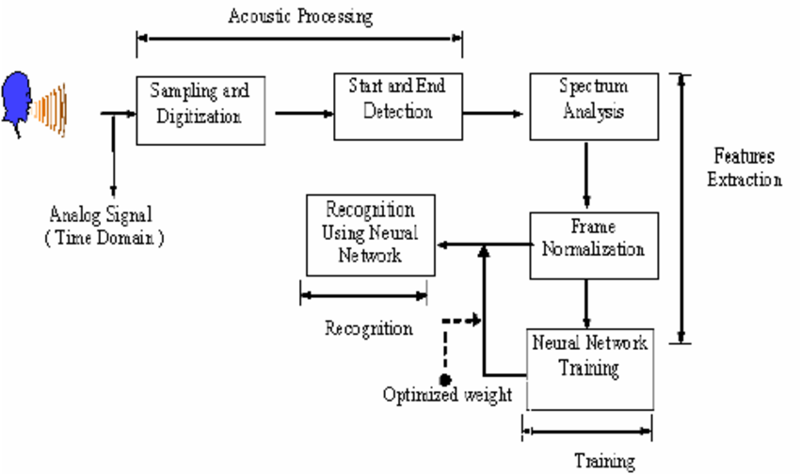
How Deep Learning Contributes
1. Automatic Feature Learning
- Traditional ASR required manual extraction of features (MFCCs, PLPs).
- Convolutional Neural Networks (CNNs) and Recurrent Neural Networks (RNNs) learn feature representations directly from spectrograms or raw waveforms.
- This reduces human effort and improves robustness to noise, accents, and variations.

2. Sequence Modeling
Speech is inherently sequential. Deep learning provides tools to capture temporal dependencies:
- RNNs (especially LSTM and GRU) can model long-term context in speech.
- Bidirectional RNNs capture both past and future context for better recognition.
- Attention mechanisms and Transformers allow the model to focus on relevant parts of the input sequence without being limited by sequential processing.

3. End-to-End Architectures
Instead of separate modules (acoustic model + language model + decoder), deep learning enabled end-to-end models that directly map audio to text. Examples:
- CTC (Connectionist Temporal Classification): handles variable-length input/output alignment.
- Seq2Seq with Attention: models speech as a sequence-to-sequence translation problem.
- Transformer-based models: e.g., Google’s Speech-Transformer, Facebook’s wav2vec 2.0, OpenAI’s Whisper.

4. Scalability with Data and Compute
Deep learning thrives with big datasets and GPU/TPU acceleration. Speech recognition improved drastically when large-scale datasets (e.g., LibriSpeech, CommonVoice, YouTube transcriptions) were combined with high-capacity deep networks.
Key Advancements in Deep Learning for Speech Recognition
1. Deep Neural Networks (DNNs) replacing GMMs
- Early 2010s: DNNs started being used as acoustic models instead of GMMs.
- Reduced Word Error Rate (WER) significantly.
2. LSTMs and GRUs (Handling long sequences)
- RNN-based models improved handling of temporal dependencies.
- Bidirectional LSTMs allowed the system to use both past and future speech context.
3. Connectionist Temporal Classification (CTC)
- Introduced by Alex Graves (2006, popularized in 2012).
- Allowed end-to-end training without pre-aligned input-output sequences.
- Example: Baidu’s Deep Speech used CTC + RNNs to achieve state-of-the-art results.
4. Attention Mechanisms and Seq2Seq Models
- Attention solved the alignment problem between speech frames and text tokens.
- Enabled models to "focus" on important parts of the input.
- Widely used in neural machine translation and quickly adopted for ASR.
5. Transformers and Self-Attention
- Transformer models (Vaswani et al., 2017) revolutionized NLP and later speech recognition.
- Speech-Transformer, wav2vec 2.0, Whisper use self-attention to model long-range dependencies efficiently.
- Provide higher accuracy and robustness compared to RNNs.
6. Self-Supervised Learning
- Training on massive amounts of unlabeled audio has become crucial.
- Models like wav2vec 2.0 (Facebook AI) and HuBERT learn general-purpose speech representations from raw audio.
- Fine-tuning with smaller labeled datasets yields state-of-the-art results.
7. Multilingual and Zero-Shot Models
- Models like Whisper (OpenAI) and XLS-R (Meta) can handle multiple languages and even perform speech-to-text translation.
- This makes speech recognition accessible for low-resource languages.
Advantages of Deep Learning in ASR
- Higher Accuracy: Dramatic reduction in Word Error Rate (WER).
- Noise Robustness: Works better in real-world noisy environments.
- End-to-End Learning: No need for handcrafted features and separate modules.
- Multilingual Capability: A single model can recognize speech in many languages.
- Adaptability: Can fine-tune easily for domain-specific vocabulary (e.g., medical, legal).
Example Pipeline with Deep Learning
- Input audio → transformed into spectrogram or raw waveform.
- CNN layers → extract local acoustic features.
- RNN/Transformer layers → capture temporal dependencies.
- CTC / Seq2Seq decoder → map features to character or word sequence.
- Language model integration (optional) → improves fluency and correctness.
- Output: Transcribed text.

Q2) Explain about Autoencoder types in detail and its applications for each type.
A)
An autoencoder (AE) is a neural network trained to reconstruct its input. It compresses input x to a lower-dimensional latent code z = Encoder(x) and then reconstructs x̂ = Decoder(z). The objective is typically to minimize a reconstruction loss (mean squared error for continuous data, cross-entropy for binary/normalized data). Because the network must compress and then reconstruct, the latent code often captures useful structure (features) about the data.
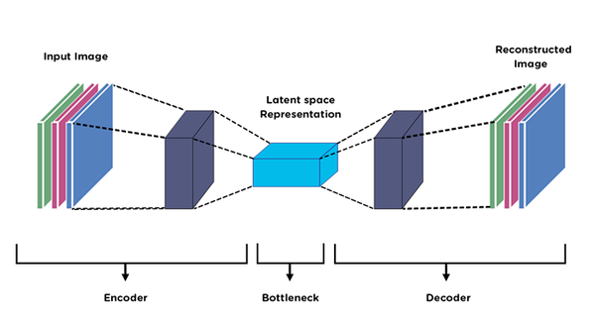
Core AE building blocks (quick recap)
- Encoder f_φ(x) → produces latent representation z (vector or distribution parameters).
- Latent space z → bottleneck; size/structure determines capacity.
- Decoder g_θ(z) → reconstructs x̂.
- Reconstruction loss L_rec(x, x̂) (MSE, BCE, etc.).
- Optional regularizers on z (sparsity, KL, adversarial loss, Jacobian penalty).
1) Vanilla / Undercomplete Autoencoder
What: A deterministic AE with a smaller latent dimension than input (bottleneck).
Why: Forces the model to learn compressed representations instead of trivial identity mapping.
Loss: Reconstruction loss (e.g., MSE).
Use-cases / Applications:
- Dimensionality reduction (alternative to PCA) — latent vectors as features.
- Pretraining for classification (learn representations, then fine-tune).
- Data compression (simple lossy compression).
Pros/Cons: Simple and effective; but can overfit if capacity is large, and features may be task-agnostic.

2) Overcomplete Autoencoder
What: Latent dimension ≥ input dimension. To prevent trivial copying, regularization (sparsity, denoising, contractive, dropout) is applied.
Why: Overcomplete + regularizer can learn richer, sparse features while preserving reconstruction.
Applications: Feature learning (sparse codes), modeling high-dimensional data when you want rich latent structure.
Pros/Cons: More flexible; needs careful regularization to avoid identity mapping.

3) Sparse Autoencoder
What: Encourage most latent units to be near zero (L1 penalty or KL-divergence to target activation).
Why: Enforces that only a small subset of neurons activate for any input → learned basis-like features (similar to sparse coding).
Loss: L = L_rec + λ * sparsity_penalty (L1 or KL between mean activation and target).
Applications:
- Unsupervised feature extraction for images and signals.
- Anomaly detection: anomalies often fail to be encoded sparsely like normal data.
Pros/Cons: Good for interpretability and local feature detectors; tuning sparsity hyperparameter is important.

4) Denoising Autoencoder (DAE)
What: Train AE to reconstruct the clean input from a corrupted version (e.g., additive noise, masking).
Why: Forces the encoder to extract robust features that capture the underlying data manifold.
Loss: Reconstruction between clean x and decoder output from corrupted input x̃.
Applications:
- Image/audio denoising and inpainting.
- Robust feature learning for downstream classifiers.
- Pretraining (stacked DAEs historically used to initialize deep nets).
Pros/Cons: Very effective at learning robust representations; choice of corruption type matters.

5) Contractive Autoencoder (CAE)
What: Add a penalty on the Jacobian of the encoder (||∂z/∂x||²) to make z insensitive to small input perturbations.
Why: Encourages representations that vary little for small changes in input → learns local manifold structure.
Applications: Manifold learning, robust feature learning, semi-supervised learning.
Pros/Cons: The Jacobian penalty can be computationally expensive for large models/dimensions.

6) Variational Autoencoder (VAE)
What: Probabilistic generative model. Encoder outputs parameters of a posterior distribution q_φ(z|x) (often Gaussian: mean & variance). Decoder models p_θ(x|z). Training maximizes the Evidence Lower BOund (ELBO).
Key math (ELBO):
Why: Learn a smooth latent space where sampling z∼p(z) and decoding produces realistic samples.
Applications:
- Generative modeling (image, speech, molecule generation).
- Data augmentation (sample synthetic but plausible examples).
- Anomaly detection (low reconstruction likelihood for anomalies).
- Semi-supervised learning (combine labeled and unlabeled via generative model).
Variants: β-VAE (disentanglement), Conditional VAE (cVAE—condition generation on labels), VQ-VAE (discrete latents).
Pros/Cons: Principled probabilistic model with continuous latent space and easy sampling; samples often blurrier than GANs; trade-off between reconstruction and latent regularization.

7) Adversarial Autoencoder (AAE)
What: Regularize the latent distribution by training a discriminator (GAN-style) to distinguish encoded latents from samples of a prior; encoder tries to fool the discriminator.
Why: Enforce any desired prior on z (e.g., Gaussian, mixture), combine AE reconstruction with adversarial regularization.
Applications: Generative modeling, semi-supervised learning (AAE variants can incorporate labels), imposing structured latent spaces (mixture models for clustering).
Pros/Cons: Combines pros of GANs and AEs; adversarial training instability is a concern.

8) Convolutional Autoencoder (CAE / Conv-AE)
What: Encoder/decoder built from convolutional and (transposed) convolutional layers instead of dense layers.
Why: Leverage spatial locality and parameter sharing for images/video; much fewer parameters and better inductive bias than dense AEs for grid data.
Applications:
- Image compression and reconstruction.
- Image denoising, inpainting, super-resolution (with architectural tweaks).
- Feature extraction for images (pretraining).
- Anomaly detection in images (industrial defect detection).
Pros/Cons: Excellent for images; must design decoder carefully to avoid checkerboard artifacts (use upsampling + conv).

9) Recurrent / Sequence Autoencoder (Seq-AE)
What: Encoder and decoder use RNN/LSTM/GRU. Encoder processes a variable-length input sequence into a vector z; decoder reconstructs a sequence from z. Can be many-to-one-to-many or sequence-to-sequence.
Why: For sequential data (text, audio, time-series) you need models that capture temporal dependencies.
Applications:
- Sequence embedding (sentence/document embeddings).
- Anomaly detection in time series (e.g., sensor monitoring).
- Representation learning for speech/audio (pretraining).
- Sequence prediction and compression.
Pros/Cons: Effective for medium-length sequences; limited for very long contexts compared with Transformers.

10) Stacked / Deep Autoencoder
What: Multiple encoder/decoder layers (deep networks). Often pre-trained layer-wise (historical) or trained end-to-end.
Why: Learn hierarchical features of increasing abstraction.
Applications: Feature pretraining, dimensionality reduction for high-dimensional datasets, initializing deep classifiers.
Pros/Cons: More expressive but may require more data/regularization.

11) Vector Quantized VAE (VQ-VAE)
What: Discrete latent space via a learned codebook (vector quantization). Encoder maps input to nearest codebook vectors; decoder uses indices.
Why: Useful when discrete representations are desirable (e.g., symbolic tokens for audio/images).
Applications:
- High-quality generative models for images and audio (e.g., WaveNet + VQ-VAE pipeline).
- Speech synthesis and compression.
Pros/Cons: Enables discrete latent modeling; training requires careful commitment/quantization loss handling.

12) Conditional Autoencoders (cAE / cVAE)
What: Condition encoder/decoder on extra information (labels, side inputs).
Why: Control generation or learn class-conditional embeddings.
Applications: Conditional image generation, controlled speech synthesis, style transfer, conditional anomaly detection.

13) Marginalized / Linear Denoising AEs (mDA / mSDA)
What: For certain noise models and linear encoders, denoising AE can be marginalized leading to closed-form solutions (faster).
Applications: Domain adaptation (mSDA), fast feature learning on tabular data.

Practical applications mapped to AE types (quick reference)
- Image denoising / inpainting: Convolutional AE, Denoising AE, VQ-VAE (for high-quality).
- Anomaly detection (images, time-series): Undercomplete AE, DAE, Conv-AE, Seq-AE (for sequences), VAE (likelihood-based).
- Representation learning / embeddings: Undercomplete, Sparse AE, Stacked AE, Seq-AE.
- Compression: Undercomplete AE, Conv-AE, VQ-VAE.
- Generative modeling / data augmentation: VAE, AAE, VQ-VAE, conditional variants.
- Pretraining / transfer learning: DAE, deep/stacked AE, Conv-AE.
- Semi-supervised learning / clustering: AAE, VAE (with mixture priors), cVAE.
- Speech / audio: Seq-AE, Conv-AE on spectrograms, VQ-VAE for discrete speech codes.
- Time-series forecasting & anomaly detection: Seq-AE (LSTM/GRU), temporal VAE variants.
Practical tips when choosing an autoencoder
- Task determines architecture: Images → Conv-AE; sequences → RNN/Transformer-based AE.
- Do you need generation? If yes, use probabilistic (VAE) or adversarial (AAE/GAN hybrids) models.
- Robustness to noise: Use Denoising or Contractive AEs.
- Want interpretable/disentangled latents? Try β-VAE or structured priors / VQ-VAE.
- Anomaly detection: Simple AEs work but performance depends on whether anomalies are reconstructable; VAEs add likelihood-based scoring.
- Compute/data budget: Simpler AEs are lightweight; deep generative AEs (VAEs, VQ-VAE) require more compute/data.

